Transformations &
First Flight
Wright Brothers National Memorial

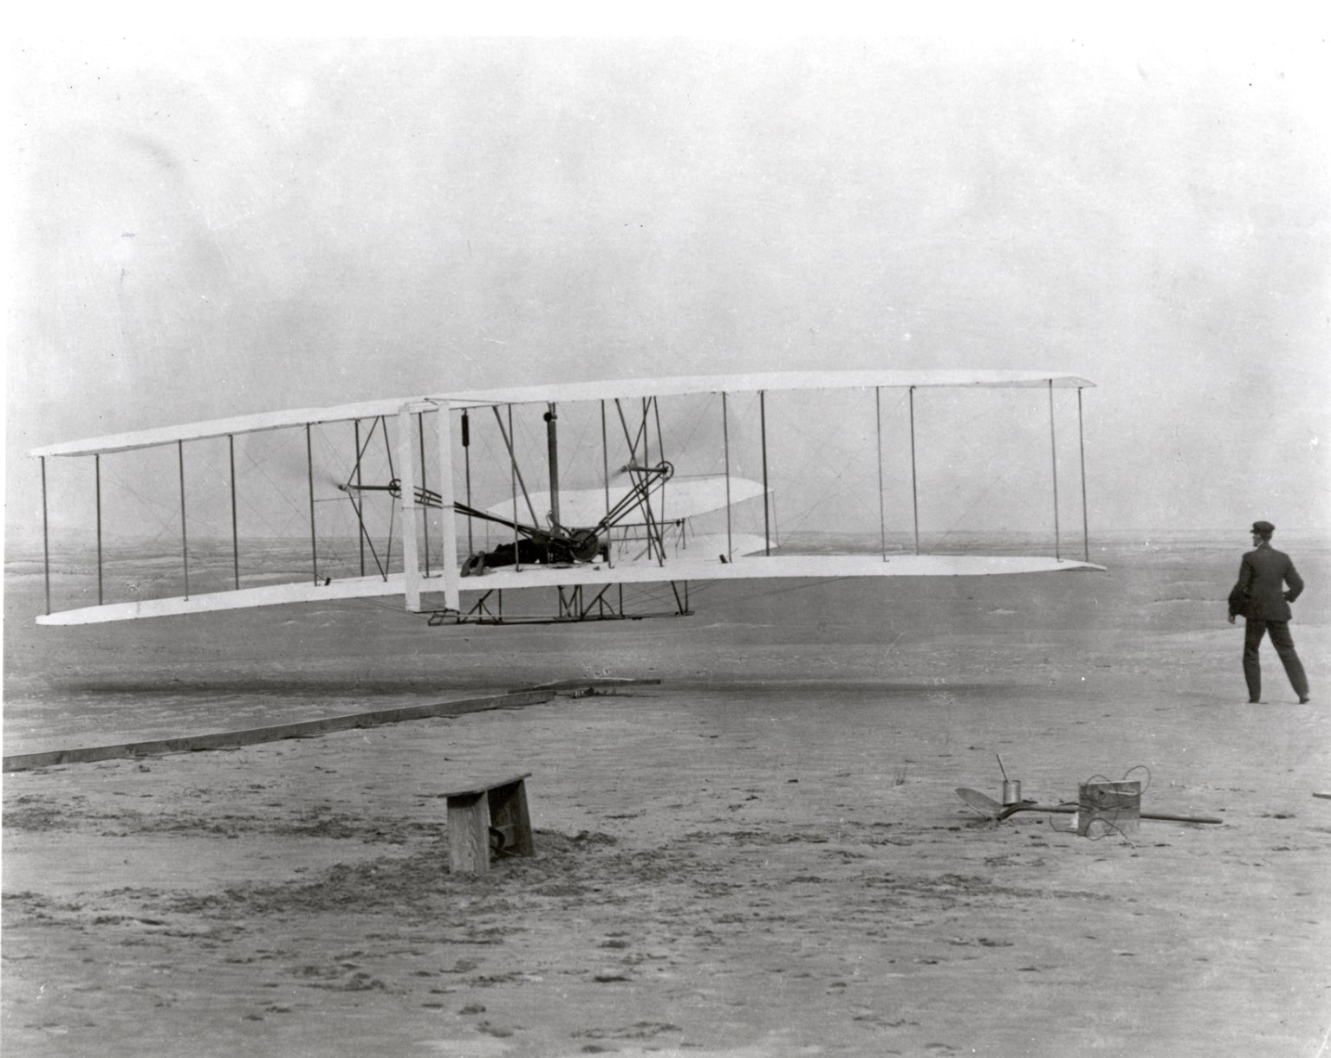

Location: In-Classroom
Grade: 8th grade
Subject: Mathematics
Duration: 90 minutes
Key Vocabulary: Translate, Reflect, Rotate, Coordinate Plane,
Symmetry

Image credit: archive.org

North Carolina State Standards: Verify experimentally the properties of rotations, reflections, and translation
Materials:

Site Significance:
Objectives: The student will be able to

Sidewalk chalk

graph paper

various recycled materials for

creation of flyers

devices/chromebooks
- translate in the coordinate plane
- reflect in the coordinate plane
- rotate in the coordinate plane
Essential Question: Do the properties of translation, reflection and rotation apply to the Wright flyer?
Method: Students will create models of the Wright flyer and translate, reflect and rotate on a classroom size coordinate plane

Site Significance:

The Wright brothers’ realization of humanity’s age-old dream of powered, controlled, heavier-than-air flight at this site permanently transformed our perception of space and time, and changed the world forever.

Background: Near Kitty Hawk, North Carolina, Orville and Wilbur Wright make the first successful flight in history of a self-propelled, heavier- than-air aircraft. Orville piloted the gasoline powered, propeller-driven biplane, which stayed aloft for 12 seconds and covered 120 feet on its inaugural flight.

Suggested Procedure

1. Students will create a model of the Wright Flyer out of recycled materials using their creativity and modeling after the original flyer. Students will research the flyer to model it more accurately
2. The flyer should be no more than 12” by 12”
3. Students will create a coordinate plane with chalk outside on blacktop, labeling the x and y axis’, the origin, the quadrants and their signs, and the horizontal and vertical axis’ should be marked in equal increments
4. Students will translate, reflect and rotate their flyers in the drawn coordinate planes based on the following rules:
a.) beginning at the origin translate 3 units up and 6 units to the right: record the new coordinates of the flyer and take a picture with device/Chromebook
b.) from previous location after translation, reflect the flyer over the y-axis and then again over the x-axis; record the new coordinates of the flyer and again take a picture with device.
c.) from previous location after reflection, rotate the flyer 90 degrees clockwise about the origin; record the new coordinates of the flyer and take a picture once again.
5. Describe the symmetry of the flyer.

Evaluation Rubric:
Students will be evaluated on each step and picture using a Rubric. Students will then describe how these mathematical concepts applied to the actual first flight and navigation.
Link to general rubric:
https://mwsu.edu/academics/education/_assets/files/st/part-one/performancetaskrubric.pdf

Extensions:
Create your own rules for translating, reflecting and rotating on your coordinate planes and have a peer model those rules with their flyer then switch. Evaluate each other.

Additional Resources
Websites:
https://www.ixl.com/math/
https://airandspace.si.edu/exhibitions/wright-brothers/online/fly/1903/triumph.cfm
https://www.loc.gov/item/today-in-history/december-17/
https://www.history.com/this-day-in-history/first-airplane-flies
Books:
The Bishop’s Boys: A Life of Wilbur and Orville Wright by Tom Crouch

